Development of Smart Village for Better Lifestyle of Farmers by Crop and Health Monitoring System

Deepak Kumar (Student CHE)

*Department of Chemical Engineering, B.I.T. Mesra, Ranchi-835215(JH), India*

deepakjsr25@gmail.com

*Abstract*— This manuscript is based on the use of IOT to help farmers by crop monitoring . This manuscript demonstrates the smart way to monitor farm conditions using IOT. Gathering the data and clubbing them to analyse the conditions prevailing over the field. With the help of this data we can reach out to them and help them. The idea demonstrated here is simple, cheap and effective. Usefull in running several tests on the soil before starting plantations. We are using quality sensors which will measure almost all the factors that are needed to be considered when we are testing the land. It will be helpful in measuring the salinity level of the sand, water content, temperature, humidity and the air quality of the surrounding environment which will be of great help in analysing farm conditions. This task will be perform in Raspberry Pi which is a single board computer with wireless LAN and Bluetooth connectivity,Seed sunlight sensor, Soil moisture sensor serving there purpose as their names are. Not only hardware but we also need an IDE platform, Arduino, to make all the components mentioned above work together.

*Keywords - Raspberry Pi4, Arduino UNO & Geneiino UNO ,Seed sunlight sensor , Soil moisture sensor and Arduino IDE. Sigfox .*

1. INTRODUCTION

Many of us come from farming background and know how much effort is needed in farming. Farmers face problem such as water shortage,low fertility,pest attack,disease attack,low yield and variety of monetary problems. I think our first concern should be crop health before marketing because marketing is possible only if the crops are fine. Some farmers in India have adopted to poly house farming which uses IOT. Polyhouse farming is farming under full controlled condition., temperatures humidity, water fertilizers every thing is automated. Setting up a polyhouse will take much time but till then we can use small setup as described in this manuscript.There are some insects which feed on plants and are not seen by naked eye which can be detected by high resolution cameras and machine learning algorithms. Farmers should opt for water saving micro-irrigation technique like drip and sprinkle irrigation.These problems can be sorted out by respberry,arduino and sigfox if used wisely.

Arduino is Development Board used for making Projects & few end-Products. You can consider it as a Micro-controller transformed for a modern world. Its Customization is possible but it already comes in many variants.Farming can only be improved by introducing latest technology. Implementing the these projects on feild can help us

How It is useful :

We can check the moisture of soil time to time and tell farmers when to irigate and when not.

We can create artificial sun using LEDs in a certain range of wavelengths.

control over temperature and humidity.

It can be used to learn programming for Electronics Engineers as well as Computer Science Engineers for building a useful design.

Understanding the Hardware-Software relationship to make any useful device can be understood very thoroughly.

To Understand the concepts of any Internet of Things

Project.

We will take the help of Sigfox for between circuits and display. Sigfox provides low powered wireless network connectivity. Better than wi-fi , bluetooth or zigbee. Sigfox is the new wireless technology, it falls under what we called LPWAN (Low Power Wide Area Network). Sigfox offers very low power bi-directional wireless communication for small devices, enabling the growth of IoT(Internet of Things) and also IR4.0 (Industry Revolution 4.0)

The suitable action can be taken against this problem by first analysing the situation. The data which needs to be collected are.

1. The intensity of light.

2. Soil moisture .

3 . Other factors through sensors.

Israel is using high quality sensors , drones , high resolution cameras and GPS for monitoring farms . We lack such technology but we can start with small setups. Transportation and marketing comes into picture when the crops are healthy.

Our work is to connect raspberry pi to Arduino and Arduino to the sensors for observing condition on the farm and then sending the data through Sigfox to farmers through email ,

sms , app or website and preparing a e-card for crop safety.

The paper is constructed in following manner :- Raspberry pi working information is provided in Section 2. Raspberry pi 3 Model B working is explained in Section 3. Arduino Uno and its communication through Sigfox is explained in Section 4. Last section is conclusion followed by references.

**III. RESPBERRY PI WORKING**

RASPBERRY PI is a development board in PI series. It can be considered as a single board computer that works on LINUX operating system. The board not only has tons of features it also has terrific processing speed making it suitable for advanced applications. PI board is specifically designed for hobbyist and engineers who are interested in LINUX systems and IOT (Internet of Things).

RASPBERRY PI platform is most used after ADRUINO. Although overall applications of PI are less it is most preferred when developing advanced applications. Also the RASPBERRY PI is an open source platform where one can get a lot of related information so you can customize the system depending on the need.

Here are few examples where RASPBERRY PI 3 is chosen over other microcontrollers and development boards:

1. Where the system processing is huge. Most ARDUINO boards all have clock speed of less than 100MHz, so they can perform functions limited to their capabilities. They cannot process high end programs for applications like Weather Station, Cloud server, gaming console etc. With 1.2GHz clock speed and 1 GB RAM RASPBERRY PI can perform all those advanced functions.

2. Where wireless connectivity is needed. RASPBERRY PI 3 has wireless LAN and Bluetooth facility by which you can setup WIFI HOTSPOT for internet connectivity. For Internet of Things this feature is best suited.

3. RASPBERRY PI had dedicated port for connecting touch LCD display which is a feature that completely omits the need of monitor.

4. RASPBERRY PI also has dedicated camera port so one can connect camera without any hassle to the PI board.

5. RASPBERRY PI also has PWM outputs for application use.

There are many other features like HD steaming which further promote the use of RASPBERRY PI.

Here we raspberry to connect the DFRobot Turbididity sensor. And raspberry pi is further connected to walabot crator. The pi is attached to the sigfox module for wireless connectivity to the walabot SDK installed on your pc.

Then that SDK shows the image of the object taken by walabot by radio frequency.

# **IV. Arduino UNO DESIGN AND WORKING**

Arduino Uno is a microcontroller board based on the ATmega328P (datasheet). It has 14 digital input/output pins (of which 6 can be used as PWM outputs), 6 analog inputs, a 16 MHz ceramic resonator (CSTCE16M0V53-R0), a USB connection, a power jack, an ICSP header and a reset button. It contains everything needed to support the microcontroller; simply connect it to a computer with a USB cable or power it with a AC-to-DC adapter or battery to get started.. You can tinker with your Uno without worrying too much about doing something wrong, worst case scenario you can replace the chip for a few dollars and start over again.

The Getting Started with Arduino Uno page contains all the information you need to configure your board, use the Arduino Software (IDE), and start tinkering with coding and electronics.

Arduino is microcontroller board while raspberry pi is a mini computer. Thus Arduino is just a part of raspberry pi. Raspberry Pi is good at software applications, while Arduino makes hardware projects simple.

We can connect soil moisture sensor, seed sunglight sensor and other sensors with Arduino to aquire data. This data is sent through sigfox module connected with arduino to the serial monitor and then to the other platforms.

* Ofcourse some coding is needed to configure but it’s a one time process.

* Open the Serial Monitor and check if your sensors are printing data.

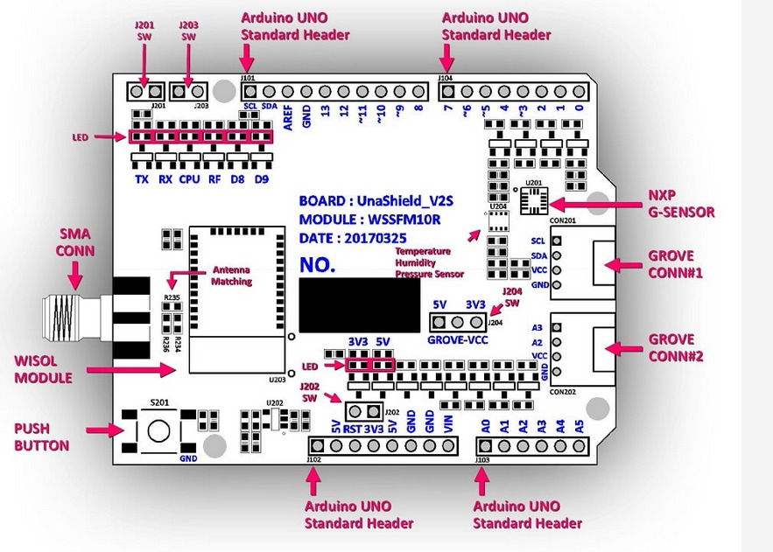

**Fig. 1** Design of an arduino UNO

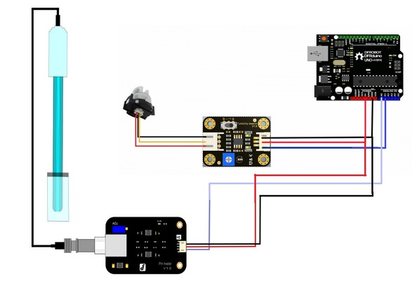

**Fig.2 Shows connection of some sensors with Arduino UNO**

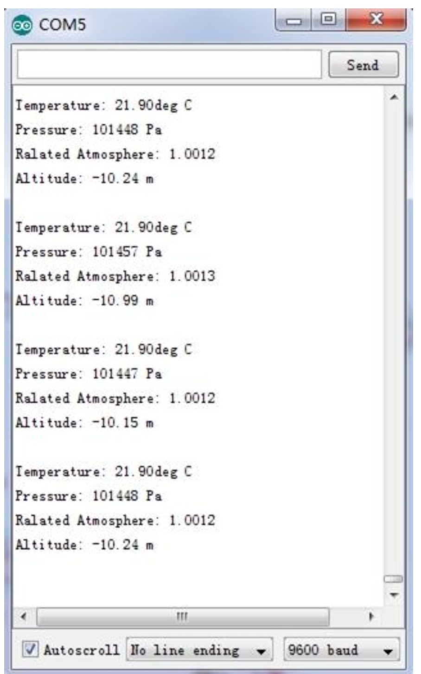

Fig. 3 Data of sensors recorded by arduino UNO

# **V. USING SIGFOX FOR DATA SHARING**

After collecting the above data we can send it to farmers and scientists . Arduino Uno is a microcontroller board based on the ATmega328P (datasheet). We are the sending the data of sensors through Sigfox. Sifgox is eco-friendly and leaves no carbon footprints. Using machine learning can help the scientists recognize the problems more specifically.

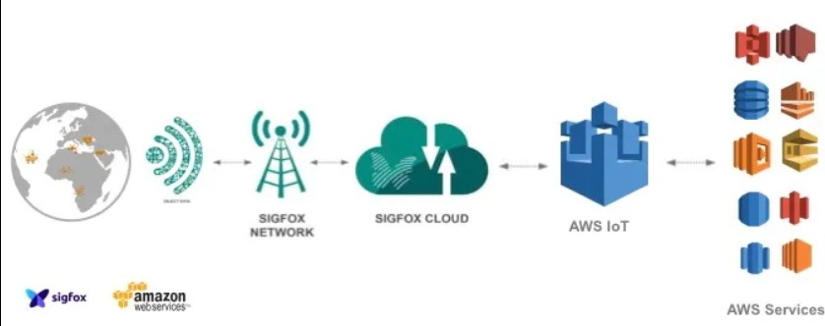

**Fig.4 Shows data tansfer natwork using sigfox and AWS IOT**

VI**. CONCLUSION**

The project is proposed to demonstrate how can we keep check on temperature , humidity , plantation technique, soil moisture and other factors. If any of the above factors change we will get notified by email or sms .The project can be made more interesting by adding some more sensors and some ML and AI works. Switching this project to a large scale can sorely help us in increasing crop productivity. Arduino and Raspberry brings new gadgets that can be implemented in our life for learning IOT.

Technology has advanced and will continue to escalate . Technology has made everything large to small and small to smaller . So it will be our loss if we don't know them , learn about them and apply them in our life.

**REFERENCES**

1. https://sigbox.com
2. https://aws.amazon.com/iot/
3. https://arduino.com
4. <https://github.com>
5. Israel21c.org
6. Microprocessors architecture, programming and applications with the 8085 by Ramesh Gaonker